**5G NETWORK OVERVIEW**

1. **About 5G**

* 5G or 5G NR (New Radio) is the fifth generation of mobile networks – promising significantly faster data transfer speeds, much lower latency, and the ability to fragment the network to virtualize a single network to support a new set of services that current mobile networks cannot meet. 5G NR is a set of technologies from the Physical layer to the Core Network that need to achieve the following three main characteristics: eMBB (enhanced Mobile Broadband), URLLC (Ultra-Reliable Low-Latency Communication), and mMTC (Massive Machine-Type Communications). eMBB includes low latency, high throughput/spectral efficiency; URLLC includes high up-to-date (low packet error rate) and low latency; mMTC includes support for large connectivity with multiple IoT devices operating simultaneously with low power requirements.

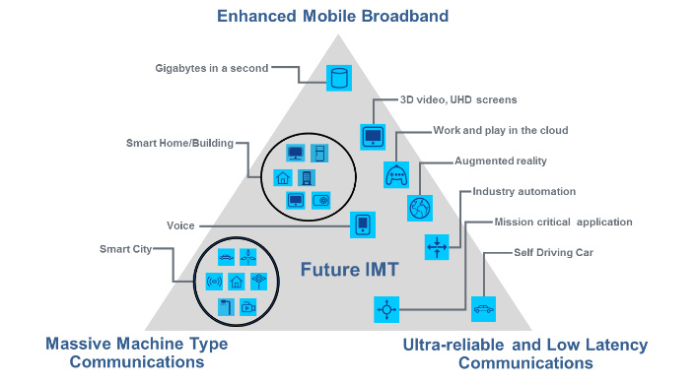

* Compared to 4G networks, 5G NR has the following advancements:

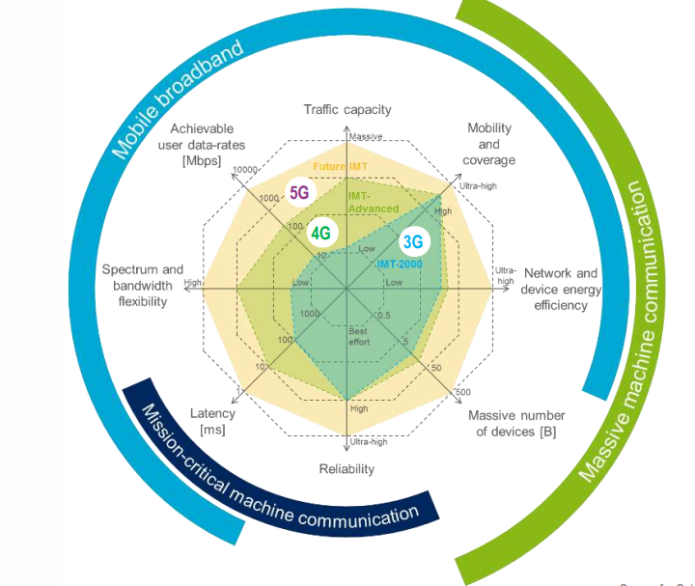

* Some of the supporting technologies of 5G are different from 4G as follows:
* Two frequency bands:
  + FR1 (410 MHz – 7.125 GHz): Bands numbered from 1 to 255
  + FR2 (24,250 – 52,600 GHz): Bands numbered from 257 to 511 (Often referred to as mmWave)
* Requirements scalability for different use cases/frequency ranges
  + Extended Numerology: subframe structure and bandwidth of the carrier component
  + Introducing mini-slots for low latency
* Up to 400 MHz channel bandwidth for each component carrier
* 3D Beamforming Antenna: MU-MIMO is navigable for each UE, wide-area MIMO
* Layer 3 (OTA) based on 4G but enhanced to optimize control plane performance
* Lower layers in 5G NR are significantly enhanced for required data rates, latency, and performance

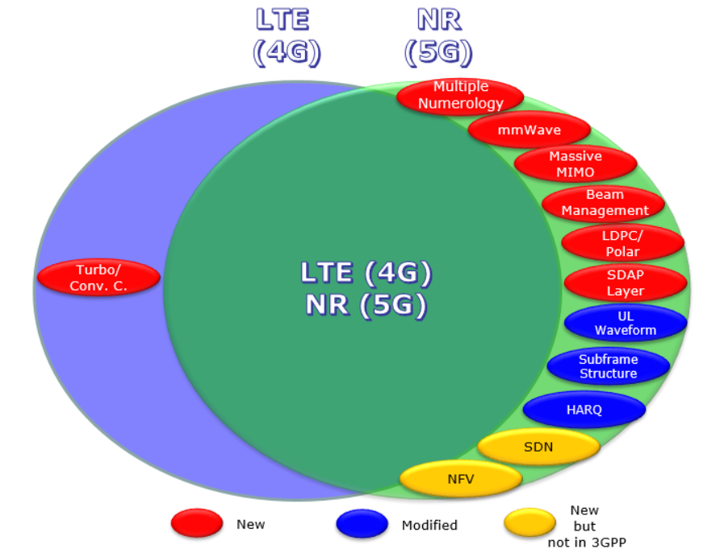

* Comparative specifications between 4G LTE and 5G NR:

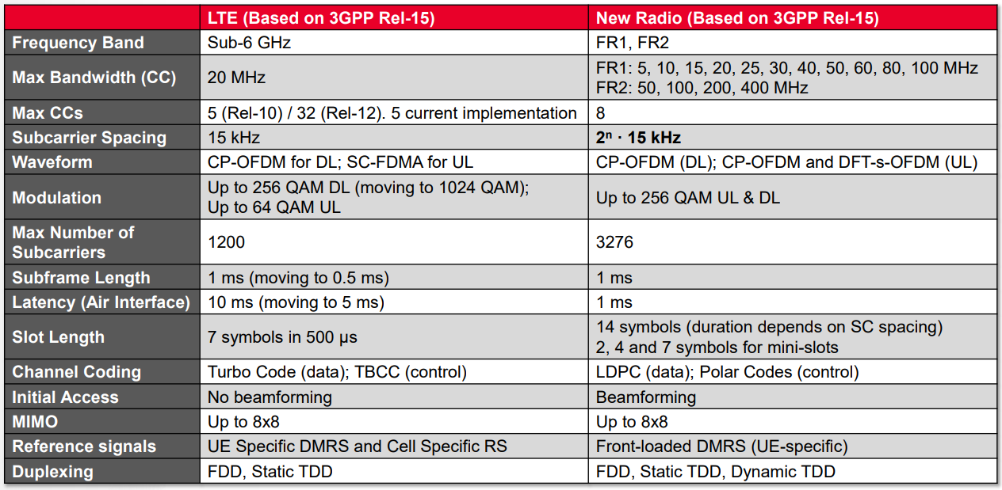

1. **5G Network Architecture Overview**

* 

1. **NSA – SA deployment model**

* The current 5G NR network is deployed on 2 models: NSA (Non-standalone Architecture) and SA (Standalone Architecture).

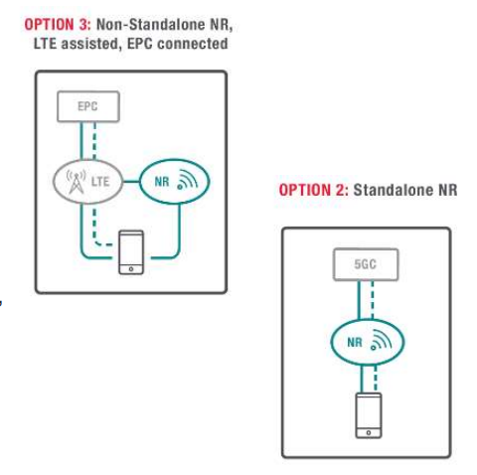

* The NSA model (Option 3) has the following characteristics:
* A radio access network (RAN) includes:
* eNodeB 4G is the main node
* gNodeB 5G is a secondary node
* Core technology: 4G core network
* Advantage:
* Fast deployment: use the original infrastructure of the 4G LTE network, just add 5G gNodeB
* Increased throughput compared to 4G LTE networks
* Shortcoming
  + Only supports MBB (Mobile Broadband)
  + Complex operation

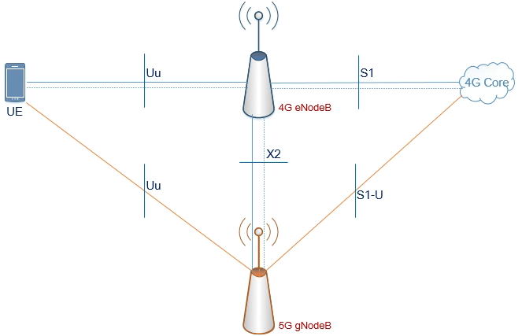

* The SA model (Option 2) has the following characteristics:
* Radio Access Network (RAN): gNodeB 5G
* Core technology: Core 5G (5GC) core network
* Advantage:
  + Achieve complete 5G technology: MBB (Mobile Broadband), URLLC (Ultra-Reliable Low Latency Communications), and mMTC (Massive Machine-Type Communications)
  + Simpler operation

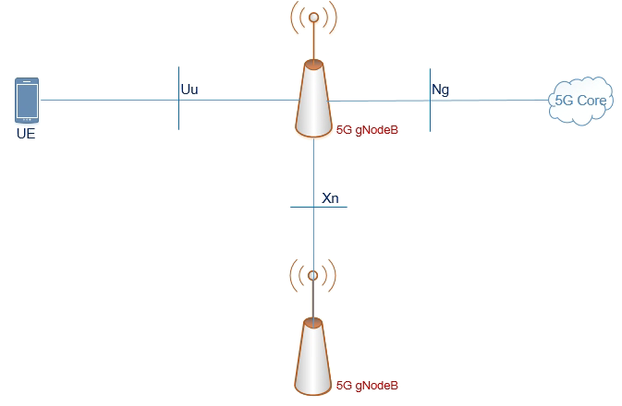

1. **Network Interfaces trong 5G**

* An interface is a connection point between two or more components in a network. It specifies how data is communicated and exchanged between different devices or network components, in order to ensure efficient and uniform data transmission.
* In the 5G NR network, there are the following types of interfaces:

1. **NG Interface**

* **NG User Plane**
* The NG User Plane Interface in a 5G network is an interface between gNodeB (gNB) and UPF (User Plane Function). This is the interface responsible for transmitting user data from mobile devices to services on the core network and vice versa. The Protocol Stack is depicted as follows:



* GTP-U Support: This interface uses GTP-U (GPRS Tunneling Protocol - User Plane) to encapsulate and transmit user data. GTP-U is a protocol that helps route packets in a 5G network, ensuring that data is forwarded to the correct address.
* **NG Control Plane**
* NG Control Plane Interface (NG-C) in 5G networks is the interface between gNB and AMF (Access and Mobility Management Function) in 5G core networks. This interface is responsible for managing and controlling the signal between the user device and the 5G core network, which plays a critical role in coordinating mobile device activities and maintaining network connectivity. Protocol stacks are described as follows:



* The transport layer is built on an IP network. In order to reliably transmit signal messages, SCTP is added on top of the IP layer. The application layer signaling protocol is called NGAP (NG Application Protocol). The SCTP layer provides the ability to ensure the transmission of messages at the application layer. During transportation, point-to-point transmission of the IP layer is used to transmit the signal PDUs.
* The NG-C provides the following functions:
  + NG interface management;
  + UE context management;
  + UE mobility management;
  + Transport of NAS messages;
  + Paging;
  + PDU Session Management;
  + Configuration Transfer;
  + Warning Message Transmission.

1. **Xn Interface**

* **Xn User Plane**
* The Xn User Plane Interface (Xn-U) in a 5G network is a user data interface between gNodeB (gNB) base stations, which allows data to be exchanged directly between base stations rather than over the core network. This interface is crucial in maintaining connectivity and efficiently transmitting data as users move between the coverage areas of different gNodeBs. Protocol stacks are described as follows:



* The transport layer is built on IP and GTP-U is used on UDP/IP to transmit the PDUs of the user plane. The Xn-U interface uses GTP-U (GPRS Tunneling Protocol - User Plane), like the N3 interface, to encapsulate and transfer user data between gNodeBs. GTP-U helps route and ensure that user data is relayed correctly between base stations.
* The Xn-U provides non-guaranteed user plane PDU transmission and supports the following functions:
* Data forwarding
* Flow control
* Rapid Handover Support: When users move from the coverage area of one gNodeB to another, the Xn-U interface allows user data to be forwarded directly between gNodeBs, maintaining a seamless connection without interruption.
* Low-latency data transfer: By eliminating the need to traverse the core network, Xn-U reduces data transfer time between gNodeBs, which is especially useful in applications that require low latency such as gaming, video calling, and URLLC (Ultra-Reliable Low Latency Communications) services.
* **Xn Control Plane**
* The Xn Control Plane Interface (Xn-C) in 5G networks is a control plane between gNB base stations, helping to manage and coordinate control operations between gNodeBs, especially in supporting handover and managing resources effectively. Xn-C ensures that user data is transmitted continuously as users move from one gNodeB's coverage area to another's gNodeB coverage.
* The transport layer is built based on SCTP on the basis of IP. The application layer signaling protocol is called XnAP (Xn Application Protocol). The SCTP layer provides the ability to ensure the transmission of messages at the application layer. During transportation, point-to-point transmission of the IP layer is used to transmit the signal PDUs
* The Xn-C interface supports the following functions:
* Xn interface management
* UE mobility management, including context transfer and RAN paging
* Dual connectivity

1. **Uu Interface (Radio Interface)**

* Uu Interface in 5G networks, also known as Radio Interface, is a radio interface between UE (User Equipment) and gNodeB. It is one of the most important interfaces in the 5G network because it is responsible for transmitting data and control signals from the user's device to the base station and vice versa, through radio bands.
* Uu Interface is a radio interface, acting as a bridge between user devices and 5G mobile networks, helping to transmit data and control signals from UE to gNodeB and vice versa.
* User Data Transmission (User Plane): Uu Interface transmits data (such as video, audio, application data) from the user's device to the network and vice versa.
* Connection Control and Resource Management (Control Plane): Uu Interface transmits control signals between UE and gNodeB, helping to establish and manage connections, control the handover process, and adjust resources to meet quality of service (QoS) requirements.

1. **GNB Protocol Stack**

* The following image shows the protocol overlay for the user plane and control plane, the functions of which will be presented in the layers section:

|  |  |
| --- | --- |
| **User Plane** | **Control Plane** |
|  |  |

* Add improvements to the lower layer (e.g., beamforming)
* Security Improvements in NAS and PDCP
* Service Data Adaptation Protocol (SDAP): a new protocol layer for managing QoS (Quality of Service)
* PHY (Physics class) sees the biggest change

1. **gNB Overview**

* The gNodeB architecture in 5G (gNB – Next-generation Node B) is an important part of the radio access network in the 5G network. It performs the basic functions of evolved NodeB (eNB) in a 4G network, but is improved and supports new 5G network features such as high data rates, low latency, and the ability to connect millions of devices. GNodeB acts as a base station in the 5G radio network, connecting to the 5G terminal (UE) and core networks through interfaces
* The gNodeB architecture is divided into three main parts based on the division of control and user functions, in order to enhance scalability and optimize network performance:

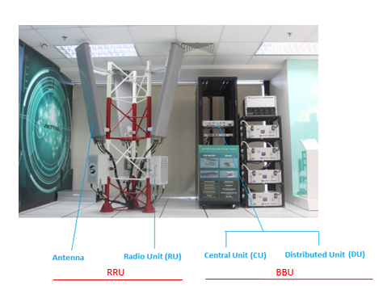

* gNodeB CU (Centralized Unit):
  + Contains the main control functions of gNodeB such as RRC, PDCP, and a large part of the core network layer.
  + Manage connections, security, resource allocation, and traffic management
  + Connect to the AMF in the 5G core network via the NG-C interface.
  + The main function of the CU is to ensure communication between the gNB and the 5G core network.
* gNodeB DU (Distributed Unit):
* Acts as an intermediary layer, processing baseband signals, forwarding data, and synchronization.
* DU optimizes the transmission of data and control signals between the core network and the radio interface.
* Manage direct radio connections between gNodeB and UEs through radio interfaces.
* gNodeB RU (Radio Unit):
  + The part responsible for processing radio signals at the lowest level.
  + Communicate directly with UEs and send/receive data over radio frequencies.
  + Perform functions such as modulation, demodulation, broadcasting, and reception.

1. **gNB Architecture**

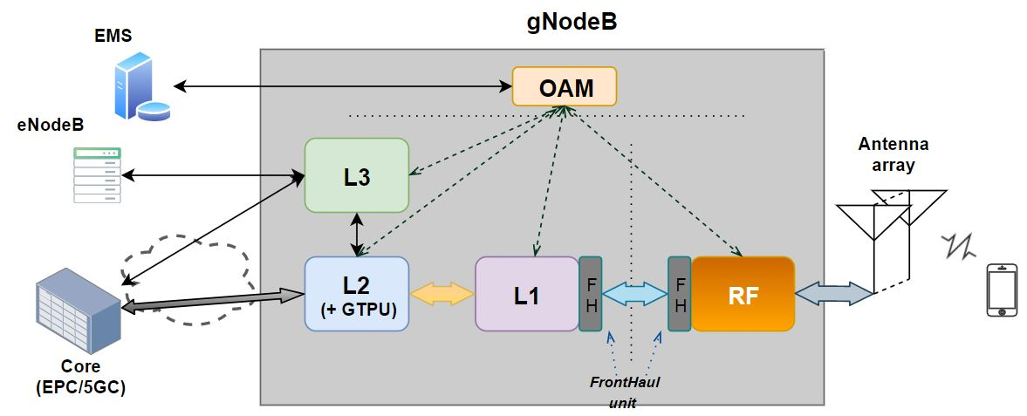

* OAM (Operations, Administration, and Maintenance) in 5G is a set of processes, tools, and protocols used to monitor, manage, and maintain a 5G network. It helps network service providers monitor, configure, optimize, and troubleshoot 5G network components.
* EMS (Element Management System) in 5G is a system that manages the components of a radio network, including gNodeB (next-generation base station) and other devices in a 5G network. EMS is designed to provide the ability to monitor, configure, maintain, and optimize network components, thereby helping network operators manage devices and hardware in radio networks efficiently.